Focus Statement: Pro-life group loses status at the University of Ottawa
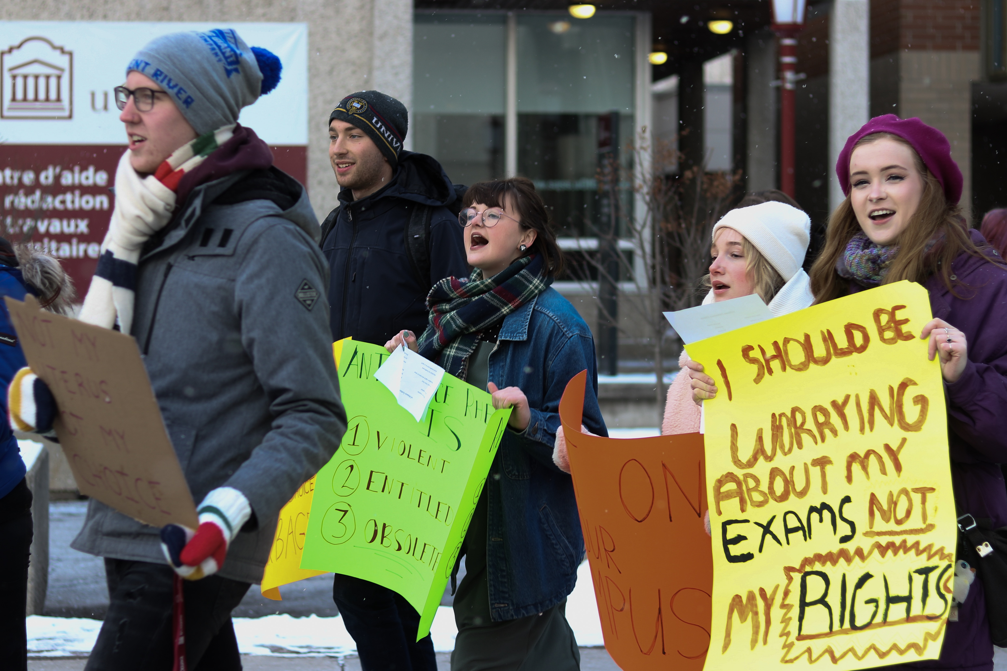

UOttawa students protesting before GA. photo taken by Emma Jackson

Contacts:

Joyce Arthur: 604 351 0867
Ruth Shaw: 1-877-618-4275 ext. 3
Bridget Dueck: 613-863-1261
Garifalia Milousis: 647-978-5433
Jason Seguya: vieetudiante-studentlife@uosu-seuo.com
Jayde Lavoie: president@aech-chra.ca

Tensions ran high at the University of Ottawa campus first semester, as students joined the national debate on freedom of speech on university campuses, when protesting the recently resurrected presence of an anti-abortion club.

"They are advocating against basic human rights of over half the student population, spreading false medical information and making an unsafe learning environment for a lot of students," said Bridget Dueck, a fifth-year biology student at the University of Ottawa who started a petition against the club.

The University of Ottawa Students for Life (UOSFL), had their official club status revoked in 2017, after allegedly spreading graphic images in their anti-abortion activism.

The UOSFL announced on Facebook in Oct. 2019 that the club had regained preliminary club status. The club still needed the approval of the newly formed University of Ottawa Student Union (UOSU).

With official status, clubs are granted resources from the UOSU, including funding, raised by student fees paid through tuition.

UOSFL's preliminary status instantly sparked online controversy, resulting in a petition by a new group, the UOttawa Defenders of Our Campus. Over 500 students who disagree with their tuition being used to fund a pro-life club, signed the petition.

"We are not focusing on the abortion debate because there is no debate: it is a human right," said Dueck. "We are focusing on the students dictating where the resources they pay for go, making them feel safe on campus and free to access their education without any fear of discomfort or trauma caused by this group."

A special general assembly held on Dec. 7, 2019, was an attempt to stop the UOSFL from receiving official club status, but the protester's first attempt to remove the club produced failed results.

"None of us want to be here, especially during exams," said Jayde Lavoie, president of the Conflict Studies and Human Rights Association. "It shows how much our campus doesn't want this club here, not for another second."

The age-old debate of freedom of speech and expression on university campuses is nothing new to Canada. Ontario Premier Doug Ford's government mandated that all publicly assisted universities and colleges develop new free-speech policies by Jan. 1. 2019. Premier Ford wrote in a tweet that the goal of the controversial provincial rule is to create an open dialogue on campuses, without the fear of attacks or discrimination.

An open dialogue on campus to discuss pro-life options is what co-president of the UOSFL club, Garifalia Milousis, hopes to achieve.

"We are not here to advocate for a legislative change, we are just trying to start a conversation and build mutual understanding," said Milousis.

Milousis was a member of the former UOSFL club in 2017. Since the club lost official status, members have still gathered regularly to discuss pro-life activism.

"To book rooms and get funding, you need to be a recognized club. We can continue having these conversations, but it is much more difficult without official club status. It makes our presence questionable," said Milousis.

Milousis's club is not the first pro-life group to struggle in achieving status and funding at their university campus in Canada. The University of British Columbia, Alberta, and Carleton are among many schools that have banned anti-abortion clubs in the past.

Many university student unions have taken a pro-choice stance. Following student backlash in recent months, the UOSU has responded by taking a pro-choice stance on abortion and amending their clubs' code, eliminating access to union funding for any groups that advocate against access to legal abortion.

"Student unions should not be taking a political stance. It's not their job. Their job is to organize activities that students want to participate in. Their job is to provide funding for the free expression of any group on campus," said Ruth Shaw.

Shaw is the executive director of the National Campus Life Network (NCLN). The organization offers training and materials for anti-abortion university clubs in Canada, including the UOSFL. She also attended Carleton, where she was arrested for displaying graphic imagery at an anti-abortion event on campus in 2010.

"Their job is to organize activities that students want to participate in. Their job is to provide funding for the free expression of any group on campus," she said.

Should student unions take political stances? The UOSU is a political organization who some expect and encourage to be political advocates.

Joyce Arthur, director of Abortion Rights Coalition Canada, approves of the pro-choice stance taken by the UOSU. She warns that by giving an anti-abortion club official status, student unions are "endorsing the club, and basically approving of being discriminatory or harassing female students."

The UOSU Student Life Commissioner, Jason Seguya announced on Dec. 7, 2019, that under the recently amended club codes that allow the withholding of funds from clubs that advocate against access to legal abortion, the UOSFL would not receive funding. However, the club was still in preliminary recognition of club status because the petitioners fell 90 students short of reaching quorum on at the Dec. 7 General Assembly, which requires 300 students for a GA to take place. That meant the UOSFL club could not be removed at that time.

"This is not over," said Dueck, addressing the crowd who was visibly upset by the outcome. "I'll fight as hard as I can for as long as I can. It's ultimately about the students, the community saying they don't want this on campus, and I stand for my fellow students."

Dueck's dedication to the cause proved successful, and the UOSU student life committee confirmed at the beginning of the winter semester that the official club status of the UOSFL has been revoked.

"I hope that everyone can take away this great lesson from this experience: always be aware of the political climate both at University and beyond," commented Dueck on the removal of the UOSFL's club status.

-30-

