Turning the page: How a Calgary-based book club is contributing to the conversation on inclusivity
by SOLAYA HUANG NOVEMBER 21, 2020
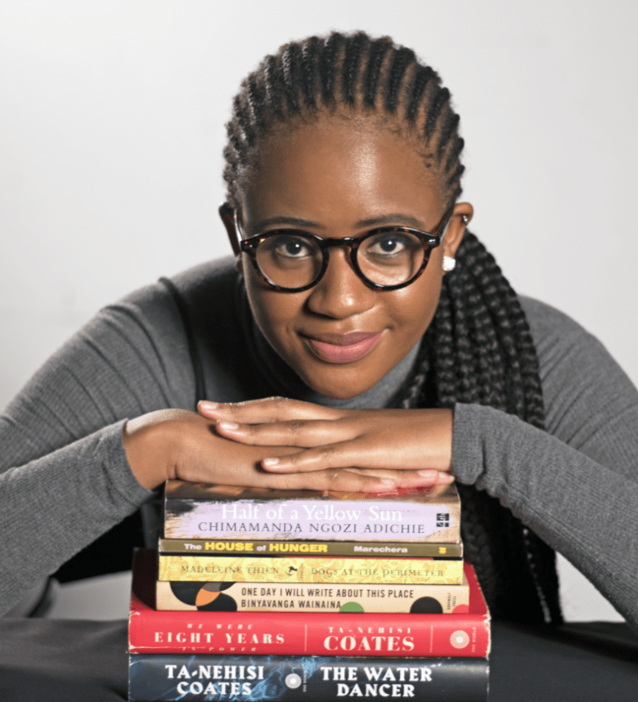

Sue-Shane Tsomondo’s main book supplier is Shelf Life Books, an independent bookstore here in Calgary. PHOTO: ANGELA LACKEY
On every holiday growing up, Sue-Shane Tsomondo was sent to her grandparents’ home in Gweru, Zimbabwe, a city that sits on the banks of the Gweru river. With no TV and nothing else to do, Tsomondo, young and bored, was forced to read as a source of entertainment.
“My grandmother was just like: ‘Here are some books – read’… In the afternoon, the TV’s off,” says Tsomondo.
And so she read. The books her grandmother owned were old, with yellow pages, strange covers and all, but they were a better alternative to boredom and would spark a lifelong passion.
After moving to Canada however, Tsomondo, now 25, discovered how Westernized the literary world was. Motivated and inspired, she created an online book club to uplift the written stories and voices of people of colour (POC) authors, as well as promote inclusivity and healing through reading.
In 2014, Tsomondo moved from Zimbabwe to Canada to pursue her degree at the University of Calgary. There, she majored in international relations, focusing on sub-Saharan Africa.
“I was really drawn to the civil society aspect of it, to the people who hold governments and people with power accountable,” says Tsomondo.
“I started to ask myself questions like, ‘Why am I reading Shakespeare in Zimbabwe?’”
SUE-SHANE TSOMONDO
In her second year, she decided to minor in English, which led her to notice the influence Western literature has, even in the country she grew up in.
“One of my required courses was Shakespeare and we studied Shakespeare in high school as well,” says Tsomondo. “I started to ask myself questions like, ‘Why am I reading Shakespeare in Zimbabwe?’”
Western literature, she noticed, had a higher academic value compared to authors and stories from other countries.
“I remember I had this one TA who would shame people for not reading certain texts – ‘Oh you haven’t read Kafka? You’re not serious about English literature,’ and I remember being very offended because I was well-read but in books that aren’t considered mainstream, that are excluded from the canon,” says Tsomondo.
This experience prompted Tsomondo to do her own research on Zimbabwean authors and literature. There, she found The House of Hunger by Dambudzo Marechera, a collection of stories reflecting on his life under white rule in Rhodesia, now known as Zimbabwe.
“I don’t even know how to describe [that book]. I think I’ve always had a hard time trying to,” says Tsomondo about the impact it had on her. “My favourite quote ever in any book is from that book. I remember just thinking: ‘Wow, his mind.’ I was so captivated, inspired.”
Those words by Marechera, which have stayed with Tsomondo since the moment she read them, go as follows:
“The underwear of our souls was full of holes and the crotch it hid was infested with lice. We were whores; eaten to the core by the syphilis of the white man’s coming.”
The House of Hunger by Dambudzo Marechera
“I am yet to read a quote that would change my life like that,” says Tsomondo.
For her, The House of Hunger represents the power of writers. The depravity and double entendre of Marechera’s words in his description of pre-independence Zimbabwe made reading the book a “life-changing experience.”
“What he represented as a writer is what I want books to do for people: To cause people to question things, to be more socially aware.”
Inspired by Marechera’s work and realizing the lack of diversity in literature, Tsomondo created Sue’s Stokvel, a book club centred around the work of Black and POC authors.
A stokvel is a type of informal credit union unique to South Africa. It’s a community where members look out for each other and make sure everyone has access to food, money, resources and support.
Tsomondo wasn’t part of a stokvel growing up in Zimbabwe but she did have Ruwadzano/Manyano, a women’s association within the Methodist Church that supported her and her single mother.

READ MORE IN THE SERIES

Turning the page: Podcasters amplify marginalized voices

Turning the page: Book club boss Sue-Shane Tsomondo’s top 10 literary picks
“They were always very loving towards me and were always looking out for me,” says Tsomondo. “When my mom got sick, they were the people who were there to visit. When she ultimately passed, they had really just taken me under their wing.”
The group still keeps in contact with Tsomondo, checking up on her regularly.
“It’s very much like it takes a village. And for me, that village was [the] Ruwadzano/Manyano community.”
Tsomondo started her own “stokvel” to hopefully encourage greater inclusivity inside and outside of reading.
“I want people to understand that [being] inclusive, you need to learn it,” says Tsomondo. “You can’t just assume that you will understand people.”
Through reading, Tsomondo believes that people can learn to value and practice inclusivity.
“[It’s] one of the easiest and most accessible ways to bring people into your line of sight,” says Tsomondo. “There are certain things that I might never experience in this life but, because I’ve read certain books, I’m aware of them.”
“For example, with Brother, I’m Dying, we had conversations about our own immigration experience. I really value that space of being able to just talk about different things and share and look [out] for each other.”
Tsomondo recommends her top 10 books that best represent her values for inclusivity, found here.
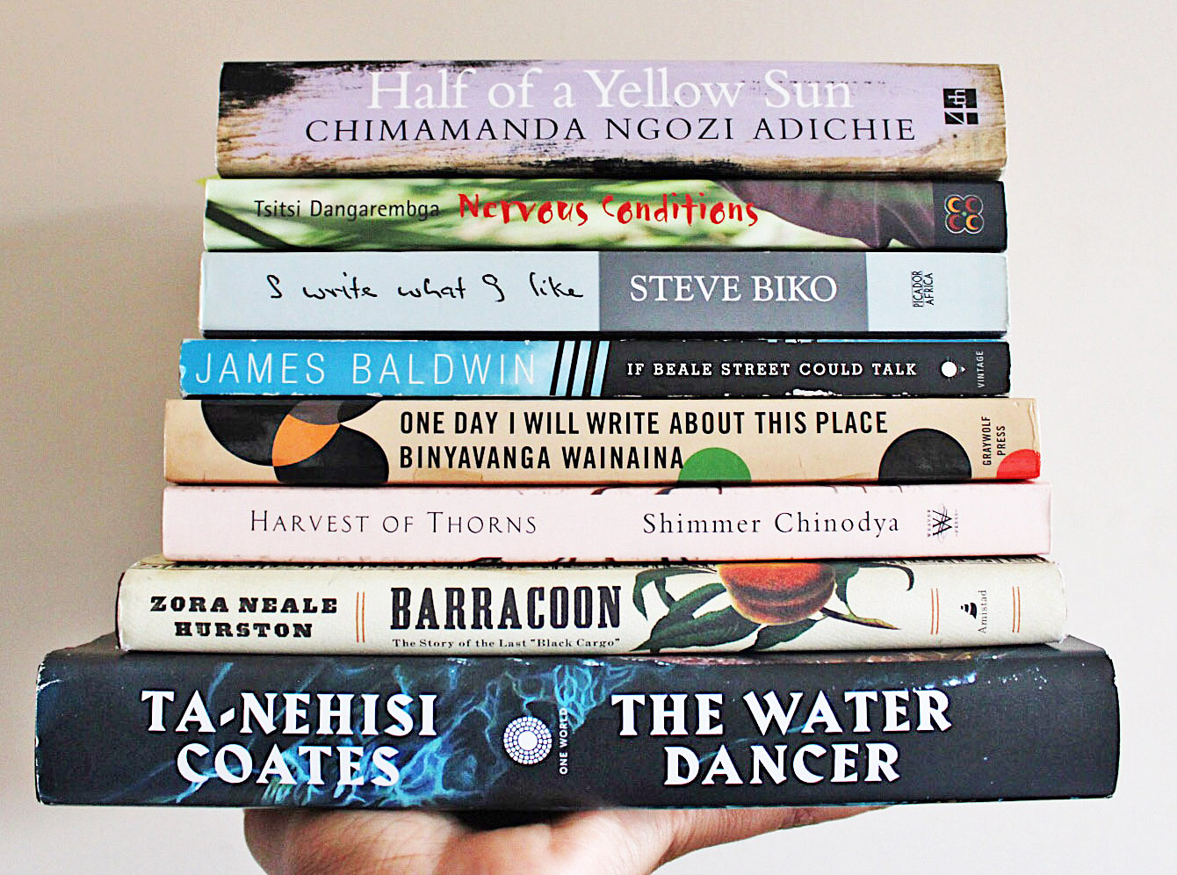A collection of some of Tsomondo’s favourite books. PHOTO COURTESY: SUE-SHANE TSOMONDO
Sue’s Stokvel started as a physical book club of around six people. Tsomondo hosted meetings in her apartment, finding books for members to discuss. But attendance soon dwindled.
The advocacy and community building that Tsomondo wanted to do with the book club is something that she says “you can’t just be interested [in], you have to be committed.”
After three short months, she decided to shut down the physical book club.
Cut to a year later: May 25, 2020.
The killing of George Floyd at the hands of Minneapolis police was not the first of its kind and not even the first of this year, but it was a catalyst the entire world responded to.
Throughout the summer, people across the world protested to end systemic racism and end violence against the Black community, all united under a single movement: Black Lives Matter.
In early June, along with the protests, came the social media initiative “Blackout Tuesday”. The idea first started with the hashtag #TheShowMustBePaused, an initiative for those in the music industry to reflect on their own complacency towards racism and to take action accordingly.
When social media users, including many high-profile celebrities, got wind of the initiative, they began posting images of black squares using the hashtags #blackouttuesday, #blacklivesmatter and #BLM. The result, however, were thousands of black squares that did little to benefit the movement. Resources, support and other essential information were drowned out.
In a reaction to this, another initiative called #AmplifyMelanatedVoices was created by activists Alishia McCullough and Jessica Wilson. This would be the next step in Tsomondo’s journey.
“[They] were like, ‘I don’t think Black people should be silent. I think this is a time to amplify melanated voices,’” says Tsomondo on the initiative.
Using the hashtag on her Instagram gave Sue’s Stokvel a needed boost.
“I was paying to keep up my website out of my own pocket…I’m purchasing books out of my own pocket, and so I posted, ‘If you would like to support an organization in a melanated voice in Calgary, there’s Sue’s Stokvel’ and I put that hashtag and it really just went from there.”
Sue’s Stokvel was then propelled into the public eye, reaching an audience of people who wanted to help. Through a surge of support and funding, Tsomondo was able to give her book club another chance. She contacted a local bookstore, Shelf Life Books, and they have since become Sue’s Stokvel’s main supplier.
“Because I had the support of the donations, it didn’t feel like I was doing it for free. It felt like something had been given to me,” says Tsomondo.
Though a lot of the support she received was out of genuine belief in her work, Tsomondo thinks it was also partially due to performative allyship.
“There’s a sort of recklessness [in just donating], like ‘Here you go, I’ve done my part’, but that’s really just the beginning,” says Tsomondo.
For her, real action isn’t reflected in financial support but in conversation.
“Okay, I’m going to donate money. But what else am I going to do? I’m going to actually try and read the books. I’m going to try and have conversations about this. I’m going to ask questions,” explains Tsomondo.
One of the main conversations Tsomondo wants to start is on the reality that Black women face – using Sue’s Stokvel to accurately represent their experiences and capabilities.
Too often, according to Kenyan conservationist and Nobel Peace Prize winner Wangari Maathai, these women are seen as bearers of culture, frozen in time. This is a perspective that Tsomondo hopes to shift through reading.
“Our traditions say that women are supposed to cook, clean and take care of their families,” says Tsomondo about Maathai’s words. “While men can dress differently, can succumb to the trends of the Western world, women are shamed for adopting Western practices.”
One of the first books that Tsomondo read involving middle-class African women was Changes: A Love Story by Ama Ata Aidoo.
Tsomondo says it had “all these interesting characters that are really not frozen in time, that are experiencing challenges that come with changes in culture, the economy (and) the political situation changing.”
“I think that we are frozen in time because it helps to control us. It is definitely an oppressive tool. But as the bearers of culture, I think we also have a lot of power and a lot of agency to change that.”
Though Sue’s Stokvel is her passion, Tsomondo has bigger plans for the future. She hopes to build a publishing company, one that not only embraces and invests in new voices in African literature but also in the voices of the past like Marechera’s.
“In Zimbabwe, a lot of books have gone out of print. That’s why someone like me, only finally when I moved to Canada, started finding out that there were all these Zimbabwean writers,” says Tsomondo. “These are well-written books; these are amazing stories and I want them to be accessible again.”
In the meantime, she has many plans for her book club, including video content and reviewing African films.
“That’s something I really would love to do because I think the connection between film and literature (is) really close, and I want to explore that,” says Tsomondo.
With COVID-19 cases still climbing, Tsomondo remains limited to the digital world. However, she is already making plans for when it’s safe to go out again.
“I definitely want to meet and engage with people,” says Tsomondo. “I would love to have (storytimes) for just African literature, to read African folklore to children of colour and Black kids.”
Reading may not be an obvious choice as a step to healing the trauma faced by the Black community, but it is one that Tsomondo is passionate about.
When opening the webpage of Sue’s Stokvel, a short phrase pops up: “Shifting the narrative and healing through storytelling.”
Tsomondo hopes that if there is one takeaway from her book club, it’s that “there’s a lot of healing and community in reading. It’s a very personal act.”
“I think for me it’s always given me the words when I don’t have them,” she says.
“There’s a specific quote from Dogs at The Perimeter by Madeleine Thien that when I read that I was like, ‘This is it. This is exactly how this feels.’”:
“Between us, she said, I had known love, I had lived a childhood that might sustain me. I remembered beauty: Long ago, it had not seemed necessary to note its presence, to memorize it, to set the dogs out at the perimeter. I felt her in the persistent drumming of water against the boat’s hull. Guard the ones you love, she told me. Carry us with you into the next life.” Dogs at The Perimeter by Madeleine Thien
© 2020 CALGARYJOURNAL.CA. ALL RIGHTS RESERVED.

